Adam Edgett

Database Design

Homework 2

# UML Diagram

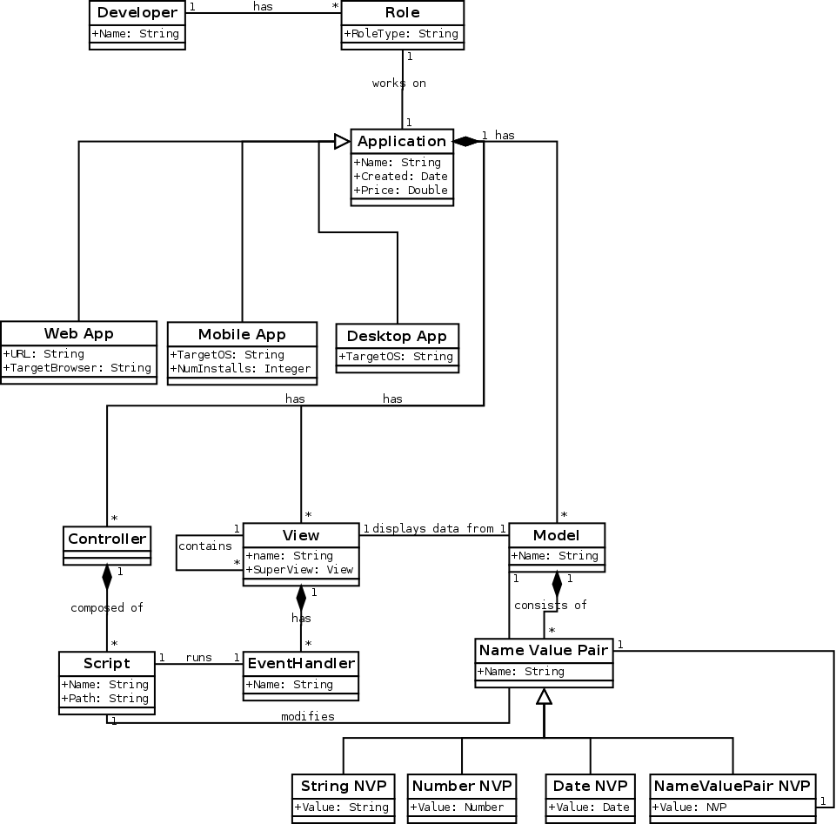

# Analysis

Due to the different but similar data types, the best way to represent the data without duplication was through an interface/implementation style class diagram.

I’ve implemented the interface/implementation classes through the use of multiple joining tables.

I’ve also implemented these generalizations as a large table with every column. But I chose to use the multiple table style because it seemed more efficient. With the single table, many fields are left blank which ends up being wasted space in the database. It also seems more difficult to validate the data with so many varying occurrences in the same table.

Also, in order to join a developer to an application, I created a Role join table to associate the two in a one-to-many relationship.

Assumptions:

Despite the fact that the class descriptions didn’t explicitly say whether some classes included name values, I’ve added names to many classes. Without these names, the data wouldn’t have much logical value. For example, there would be many unnamed Views with only the other data to use to determine what the script did.

Also, scripts did not include anything about where the script data/instructions were located. So I assumed that the script was stored somewhere on the filesystem and gave it a path.

I also created validation tables for the enumerable types. For example I created a table and populated it with the possible browser types to use for validation on the browser field.

# Results

Notes:

All tests and results done using sqlite3

Some data is truncated due to output width

RoleType

name

---------------

Business Analys

Architect

Database Admin

Back End Develo

Front End Devel

Browser

name

---------------

Chrome

Firefox

Safari

IE

MobileOS

name

---------------

Android

iOS

Blackberry

DesktopOS

name

---------------

Windows

OSX

Linux

Developer

devel_id name

--------------- ---------------

1 Adam

2 John

3 Bob

4 Tim

Role

role_id type devel_id app_id

--------------- --------------- --------------- ---------------

1 Database Admin 1 1

2 Back End Develo 1 2

3 Front End Devel 2 3

4 Architect 3 4

5 Business Analys 4 5

Application

app_id name created price

--------------- --------------- --------------- ---------------

1 Google 2014-01-31 12.0

2 Facebook 2014-01-31 20.0

3 Sublime Text 2012-05-13 70.0

4 Dropbox 2013-07-17 0.0

5 Angry Birds 2011-04-11 1.0

MobileApplication

mobileapp_id app_id targetos installs

--------------- --------------- --------------- ---------------

1 2 iOS 0

2 5 Blackberry 0

WebApplication

webapp_id app_id url targetbrowser

--------------- --------------- --------------- ---------------

1 1 google.com Chrome

2 4 dropbox.com Firefox

DesktopApplication

deskapp_id app_id targetos

--------------- --------------- ---------------

1 3 Windows

Controller

controller_id app_id

--------------- ---------------

1. 1

Model

model_id app_id name

--------------- --------------- ---------------

1 1 Searches

2 1 Results

View

view_id app_id name superview_id

--------------- --------------- --------------- ---------------

1 1 Search Results NULL

Script

script_id controller_id model_id name path

---------- ------------- -------- ---- ---------

1 1 1 search /www/js/search.js

EventHandler

eventhandler_id view_id script_id name

--------------- --------------- --------------- ---------------

1 1 1 Run Search

NameValuePair

nvp_id model_id name

--------------- --------------- ---------------

1 1 Query

2 2 Result Page 1

3 2 Search Date

4 2 northeastern.edu

StringNVP

stringnvp_id nvp_id value

--------------- --------------- ---------------

1 1 northeastern

NumberNVP

numnvp_id nvp_id value

--------------- --------------- ---------------

1 4 1

DateNVP

datenvp_id nvp_id value

--------------- --------------- ---------------

1 3 2014-02-1

NameValueNVP

nvpnvp_id parent_nvp_id value_nvp_id

--------------- --------------- ---------------

1 3 4

Application JOIN WebApplication

name created price url targetbrowser

--------------- --------------- -------- ----------- ---------------

Google 2014-01-31 12.0 google.com Chrome

Dropbox 2013-07-17 0.0 dropbox.com Firefox

Developer JOIN Role JOIN Application

name type name

--------------- --------------- ---------------

Adam Database Admin Google

Adam Back End Develo Facebook

John Front End Devel Sublime Text

Bob Architect Dropbox

Tim Business Analys Angry Birds

Expected error checking

Testing constraints

Error: near line 91: FOREIGN KEY constraint failed

Error: near line 95: NOT NULL constraint failed: Application.name

Error: near line 99: UNIQUE constraint failed: DesktopApplication.deskapp_id

Error: near line 103: FOREIGN KEY constraint failed